Brendan Clarke
CS 499
Milestone two
Inventivy Enhancement

To begin, I intended on enhancing my project built on android studio by converting the language to Swift for iOS. My original app was a barebones inventory management app that gave you ability to create, read, update, and delete items from a simple UI. Utilizing MySQL. This artifact represents my ability to utilize a new language with limited understanding of syntax and adapt my original project to it. Then It will give me the ability to showcase how I can interpret my codes original mistakes and resolve them in a meaningful way in its new form. However it was through the process of setting up my project on visual studio code that I realized it is not possible to develop an iOS app on windows and it would require a native mac machine.
So in my research I have concluded the following option,
AWS EC2 Mac Instances.
This service enables me to create a Mac computer that I can remote into from my desktop, the first 200 hours are available free on AWS. To remote in securely I had to complete the following steps,
In the setup screen I must create a key pair, selecting RSA for the type and .pem for the file format, then I will download the keypair file.
Then I must create a network security group to ensure only my IP address can access this for SSH and remote desktop.
It was however at this point that AWS requires a special authorization on my account to be able to create a “dedicated host” in order to run a Mac computer from AWS. Because of this I had to find a new alternative that I can utilize while waiting for approval for the increase to my quota on AWS.
I have found one called Scaleway, while it is based out of France, it will give me the ability to create a mac virtual machine and then remote into it.
Once I was able to setup the SSH key and then the remote desktop. I installed xCode and on my desktop on the second screen I opened up my android studio app with my code.
Guess what!
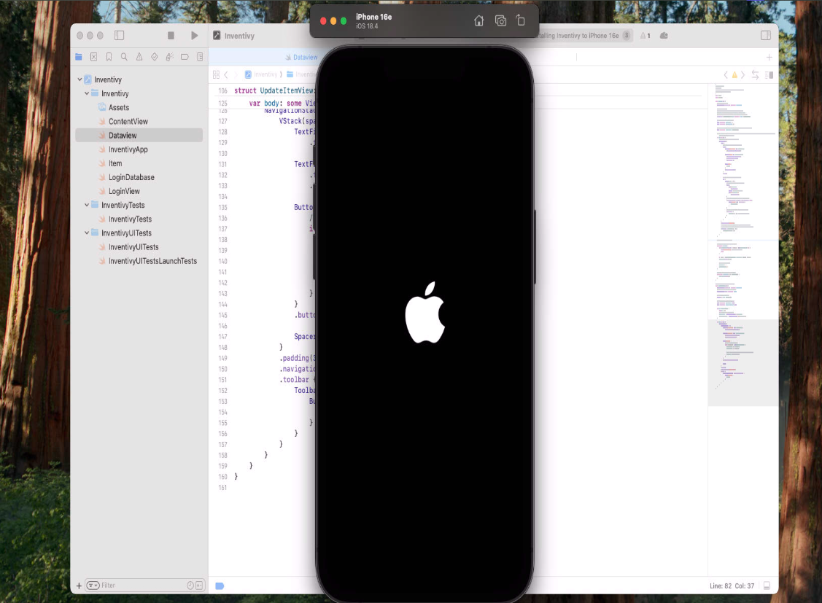
After much intubation, and attempting a multitude of ways, I have created the first few screens and attempted to update the mysql database to swift data.
Apple has create a large wiki of sorts for all things Swift.
I have been going through each function of my original code and identifying the exact alternatives in Swift.
Migrating to swift is different than just a direct translation as there are some major platform differences in how the app will utilize the architecture. However, it is very possible to make an exact equivalent on the front end.
The biggest change will by the consolidation of the UI. The XML layout files and the Java logic all got replaced by single equivalents. MainActivity.java and the login layout file became “LoginView.swift.”. Swift UI is a declarative framework where I can describe what my UI should look like for the given state, then the system automatically updates the view when that state changes. This will eliminate the need to manually find and update UI elements which results in a single reactive source.
This also shows itself in our replacement for Mysql for database management. The LoginDatabase.java class which required us to write manual SQL for creating the tables and for the CRUD actions was replaced with SwiftData. SwiftData is a ORM where you define your data model as a swift class. The framework will then handle all the underlying SQL database creation, fetching and saving. This makes a huge difference in how much uh.. “boilerplate” code there is. Which will help in interpreting our code and reduce possible syntax errors.
As mentions before SwiftUI navigation is a function of the applications state. By changing a single variable booler like isAuthenticated from false to true the UI reacts to hide the LoginView screen and then show the dashboard or the ContentView screen. This makes the flow more intuitive and a lot easier to debug.
The absence of the SMS feature is no accident, the way apple focuses on user privacy, the only way to have created a service that can send inventory updates would be by including some third-party service running independently of the software.

On to the user test interviews,
I arranged for a few friends to test both apps. This process was done via teams. I gave them control of a virtual machine running windows for the android studio test, and allowed them to access my virtual machine I setup earlier for the iOS app test.
The intention of this test was to get a sense for how some users might interpret the differences in the apps.
I set up a few questions before hand, and then left some spots opened ended for them to express their thoughts.
I then made a google survey to give each user a 1 on 1 ability to rate the differences in the apps.

User Personas:
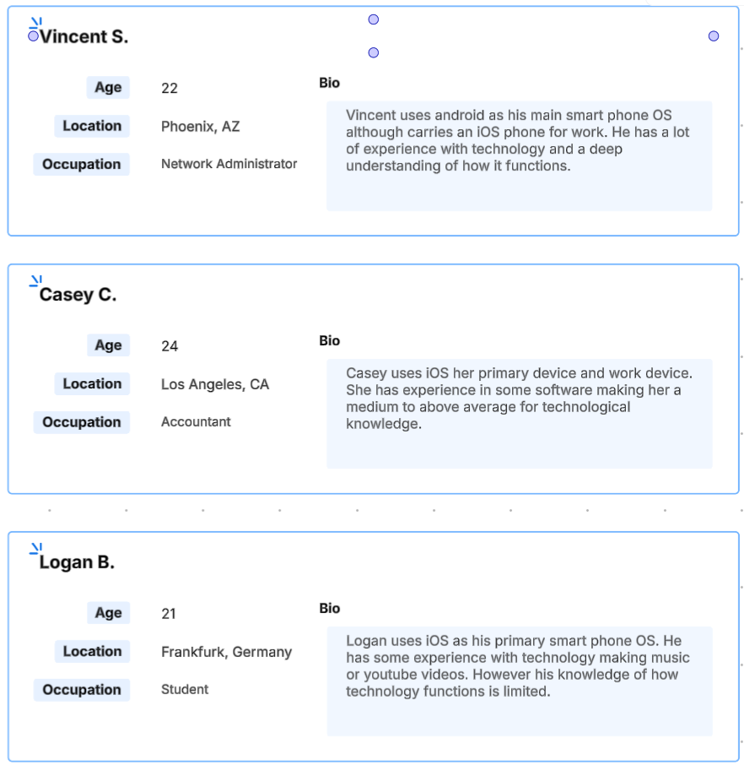

Google Survey Feedback:
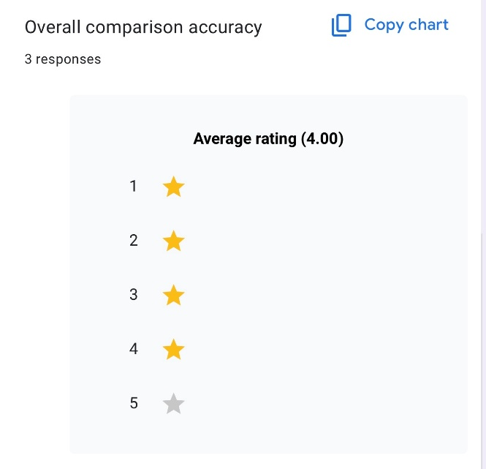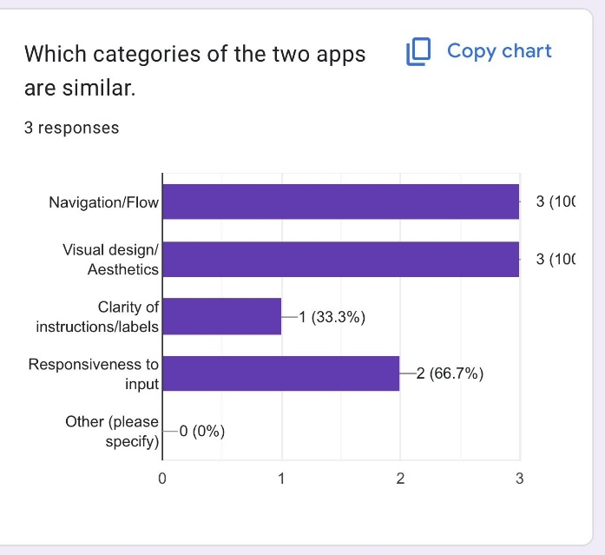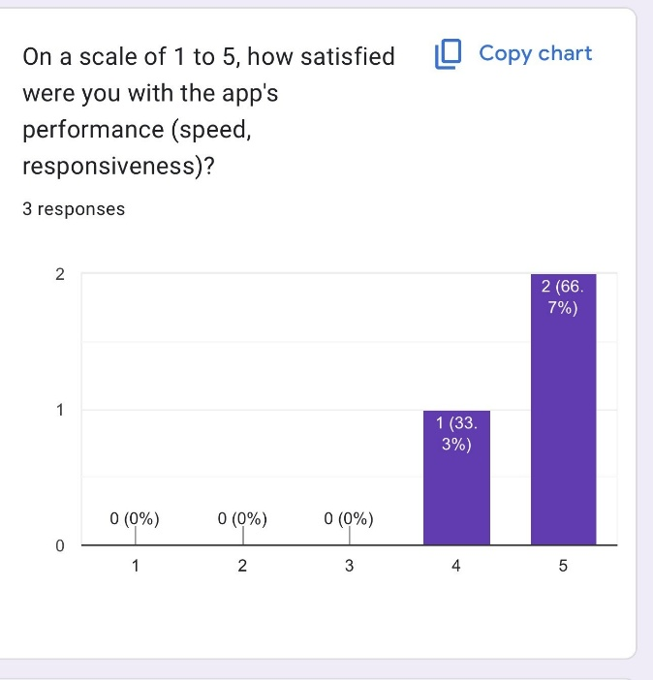
Overall, there was pretty solid reviews without any app breaking bugs.

Interview 1, Logan B.
Me: Lets go ahead and open the android app before I tell you anything about the app.
(Android studio was started and I explained the purpose of the app. We launched the simulator to emulate an android phone.)
Logan: Well, starting out it looks like a pretty simple login screen, I will try to make an account.
(Logan click the create account button and was presented with the alert that the text_fields are blank)
Logan: So I guess I need to fill this part out.
(Logan entered a test account then signed in, he started to add add items, then saw how he could edit the items by clicking on them. After deleting and adding a few, we then moved onto the iOS app.)
Me: Okay so my intention was to create the exact same experience but through swift.
(We opened the swift app and logan began using it without hesitation. Upon creating his account he was able to edit, create and delete items without issue.)
Me: Was there anything about the two apps that you notice right off the bat are different in terms of how you use it, or its functionality?
Logan: The apps appear near identical with of course the stark color differences, aside from that they felt very similar, I’d probably not notice if these were different apps if I had launched them side by side.
(Since logan has successfully achieved the goal of not noticing any functional differences, we will move onto the second interview.

Interview 2, Vincent S.
(in this part I actually wanted to run the iOS app first and then the android studio app to give a bit of randomness to the testing.)
Me: Lets go ahead and open the android app before I tell you anything about the app.
Vincent: The first glance it seems like some kind of login screen, I will try to do some inputs.
(Vincent attempted to login without a user account and was met with a message stating the fields were blank)
Vincent: Okay I’m gonna make an account then. That seems somewhat secure.
(after signing in, Vincent was able to delete the previous items created by the last interviewee and add a few more items. He wanted to test the limits and kept adding items. We then moved onto the Android studio version of the app. And he played around with it in the same way.)
Me: Was there any major difference between the two apps you noticed?
Vincent: It didn’t seem like the SMS feature was on the iOS version, and the login screen and dashboards had the same layout per say but had different colors and buttons. The screen for editing the items appeared differently as well.
Me: Do you think this caused any major differences in functionality?
Vincent: No, functionality wise it appeared the same aside from the SMS to send inventory updates.
(Since the goal was achieved we then moved onto the next interviewee.)

Interview 3, Casey, C.
(We started with the android studio app)
Me: Lets go ahead and open the android app before I tell you anything about the app.
Casey: Okay, this seems like a pretty straight forward sign in screen, I appreciate the lack of any color or items in the background kind of distracting me from what this screen is.
( Casey attempted to sign in a couple of times, before clicking the create account with the fields blank. She clicked it a couple of times before attempting to make an account. Once she filled in info it signed into the dashboard automatically.)
Casey: I like that it went straight to the dashboard, but maybe a message explaining how to use would be better on the first launch.
(Casey played around with the CRUD functions deleting, and adding items, then editing items currently listed.)
Casey: This feels very simple and intuitive, I like it.
(We then switched over the iOS version of the App.)
Casey: Oh wow, this is practically identical. Very cool.
(She signed in then used the app the same way she did in the first test.)
(This then concludes all the user tests since the goal was achieved)

Conclusion:
Apple and Android can very easily perform identical apps written in completely different languages with entirely different back ends. The iOS app was able to achieve the same functionality aside from the SMS feature as the android studio app.
I was able to successfully modify the original artifact into something that has improved its functionality, simplicity and my knowledge of Swift.
Setting up the environment to be able to use Xcode was a challenge I did not anticipate, however with the right tools it is possible to create anything. I was able to identify the best resource for creating a virtual machine to remote into, even after much deliberation.
Additionally, to that, Swift has some stark differences to android studio. Being able to locate the right information in the swift guidelines was extremely helpful in merging the logical side of the application. I think what is important is creating an app they can have the same functionality and user flow, even if they are written completely differently to one another, the output is what the user will be using and that is what is important to replicate not the exact one to one translation of the code files. This meets the course outcomes I planned to meet with my enhancement.
This process that initially gave me a few headaches I was able to demonstrate my adaptability for environments, and collaboration. The user interview portions were fun to finally put my friends to work and give a different perspective on my user flow and overall experience. This demonstrates the way I can communicate and present information to users who may not be able to understand deeper knowledge of technology. Which in any workplace can be extremely fundamental to operating on a diverse and skilled team with varying degrees of experience and wildly different perspectives.

